VICTORIAN BUSH POETRY AND MUSIC ASSOCIATION INC (5 member groups)
VBPMA Muster at Benalla
2nd weekend in October with Poets’ Breakfasts Saturday and Sunday,
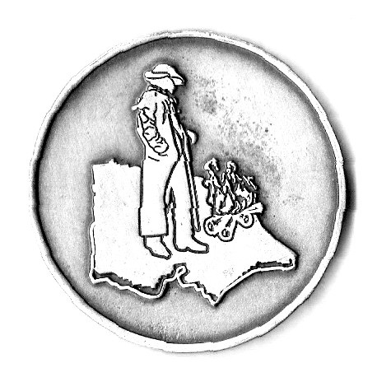 Australian Bush Poetry is family entertainment, written abut Australians and the Australian way of Life.
It is rhyming metered verse, in the style of Henry Lawson & A B (Banjo) Paterson.
We perform Traditional, Modern and Original items as Yarns, Poems and Songs.
VBPMA Secretary Jan Lewis 0260774332 Mobile 0422848707
Membership Application Form Victorian Bush Poetry & Music Association Inc.

Name: ……………………………………………… Membership number……………….
Postal address: ……………………….
Postcode:……….. Phone:…………………………. Mobile:……………………………..
Email: Facebook? ……yes/no
Signature: …………………………………..Date……………………….
VBPMA Membership Fees: (AUD) please tick/circle New or renew (tick which)
Single membership $10
Dual membership $15 in one household
Group membership $10
Junior membership (under 18 years) $5
Supporter…. Donation. $.............

Membership is for a calendar year from 2nd Sun in October to 2nd Sunday in October the following year.
Annual membership includes occasional emails/news re poetry events (also Facebook see below)
plus information for both Benalla Entertainment Muster and Man from Snowy River Bush Festival.
AGM IS HELD AT THE COMPLETION OF BENALLA MUSTER AT THE BOWLS CLUB
VBPMA will not share your details with any other group.

I do/do not require a receipt
Circle payment Method: cheque money order Direct Debit
Cheque/money order payable to Victorian Bush Poetry & Music Association Inc. TOTAL $...............
Payable to: Christine Middleton, Treasurer
P.O. Box 357, Portarlington 3223
Direct Deposit - Bank: Bendigo Bank Acc name: VBPMA Inc BSB 633000 Acc. No: 142764125 (please ref your name)
Enquiries: Tel. (02) 60774332 Email: info@vbpma.com.au
Web: www.vbpma.com.au Facebook www.facebook.com/groups/vicpoets

